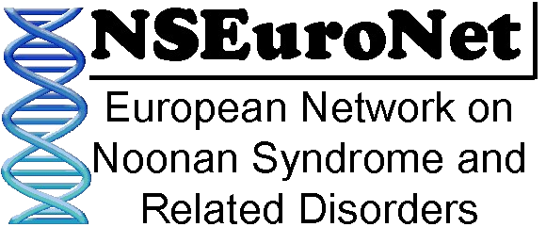
NSEuroNet Database Consent

The NSEuroNet database is a collection of clinical data and genotype information from subjects affected by Noonan syndrome and related disorders (CFC syndrome, Costello syndrome and others). It has been established to serve as a comprehensive resource of information about the spectrum of genetic variations causing Noonan syndrome and related disorders and about correlations between certain genes or individual variants in genes with the nature and clinical expression of the associated disease. Since the interpretation of individual DNA test results is based mainly on publicly available data from others who have been tested before, the information in this database helps the diagnosis of others and further understanding about the disease. Improved understanding of the molecular mechanisms of disease may be important in developing new strategies for clinical management and prevention. The database is also used to facilitate research on mutation spectra and genotype phenotype correlations, and results of such studies may be published in the scientific literature. The database can be viewed and searched online with open access. It does not contain any information on the subjects’ identity and the data that is displayed online is a summary on subjects with the same genetic variant (no individual data sets are accessible, except for genetic variants for which only one carrier subject is known to the database).

The undersigned declares:
- I agree that results of the DNA test (i.e. the identity of the genetic variant that is assumed to cause the disease) and of clinical examination (according to NSEuroNet questionnaire) from me / from the person I have the legal custody of may be added to these public data sets, in a manner that does not disclose the personal identity and that is in agreement with European data protection regulations.
- I understand that all individual data stored in the database is coded, which means that existing identifiers (e.g. a patient ID or medical file number) are removed and substituted by a proxy identifier used in the database (sequential database entry ID number). The link between the existing identifiers and the proxy identifier is only maintained by the submitter.
- I understand that despite all measures to protect my privacy / the privacy of the person I have the legal custody of, crossexamination of stored nonidentified data might indicate, but not prove, identity. The chance of identification is very low, but cannot be fully excluded in the case of rare or unique mutations or unique combinations of clinical features. Should this happen, users of the database will undertake not to explore this information further or to contact me.
- I understand that data from this database is also used for research on mutation spectra and genotype phenotype correlations and the results of such analyses may be published in the scientific literature.
- The permission for using of my / my child’s data in the database is valid without time limitation, but I have the right at any time to withdraw my consent for further use of the data. Withdrawal of consent has to be declared to the submitter (indicated below) who is the only person that is able to relate my / my child’s data set to my / my child’s person. I understand that although it will be possible to eradicate information that was originally displayed from the database, it may not be possible to eradicate it from other sources that have used this information, for example, in an overview publication.
- I understand that I will not receive any payment for this.

Name of subject: ____________________________________ Date of birth: _________________________

Signed: ________________________ Undersigened name in block letters: __________________________
Please tick as appropriate: I am the patient I am the patient’s legal guardian

Submitter name: ________________________________ Institution: _______________________________
Adress and phone number:

